**Type -2 error :** The probability of not finding a difference that

actually exists between two groups (or between sample and population).Not Rejecting null hypothesis when it is false.

Known as the β

Power is (1- β) and is usually 80%

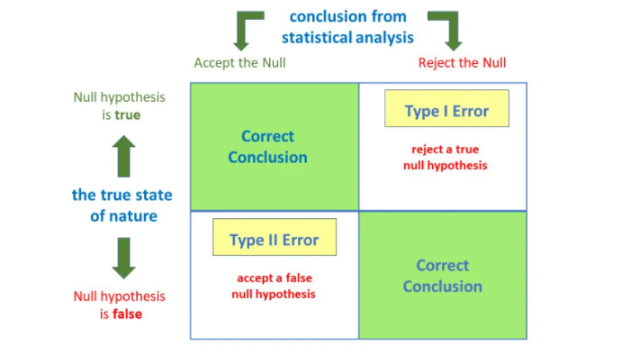

**Problem :**

From the population of players in the T20-WC batting dataset, a sample of 49 players have been selected and their corresponding matches and innings are noted down. Calculate the observed power of innings as matches(Category values) are fixed, and calculate value of β. (assuming α=0.05)

Solution :

H0 : There is no significant relationship between matches played by the players(category value) and innings scored by them.

H1 : There is a significant relationship between matches played by the players(category value) and innings scored by them .

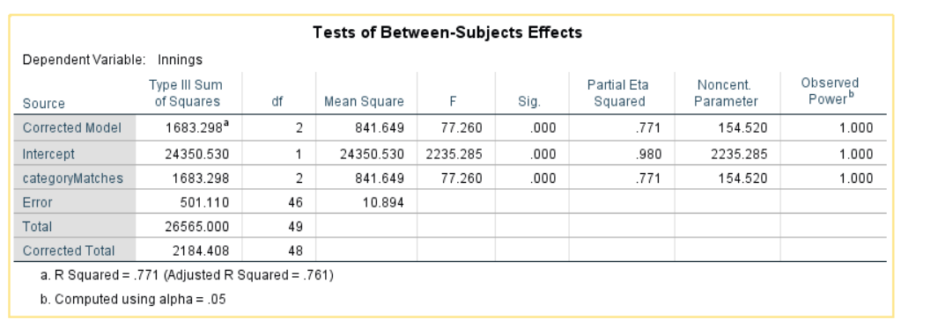

*Table: 1 - Table containing observed power and significance*

From the table we get power of innings

Power = 1(100%)

i.e, 1-β =1 => β=0

This indicates the probability is 100% of rejecting the null hypothesis when it is false.

Therefore accept H0.